Using Blue Cards 9.08
Joseph Lewis
Table of Contents
Chapter 1: About Blue Cards 3
1.1.What it is: 3
1.2.License 4
Chapter 2: Using 5
2.1.Introduction 5
2.2.About Decks and Cards 6
2.3.Creating a New Deck 6
2.4.Opening an Existing Deck 6
2.5.Saving a Deck 7
2.6.Importing an Existing Deck 7
2.7.Opening a Card 7
2.6.Creating a New Card 7
2.6.Deleting a Card 7

Chapter 1: About Blue Cards
1.1.What it is:

Blue Cards 9.08 is an intuitive, easy to use program that allows you to create, edit, and import index card files. Blue Software is software that is easy to use, because it easily transfers skills from real life to software. The version number (9.08) is the year the software was released then a dot then the month this makes it easy for you to know how old the software you are using is.

Blue Cards is:
- Cohesive, has few undesirable traits.
- Maintainable, no changes needed to operate on other systems.
- Correct, few faults, none will crash the program
- Reliable, runs on a stable architecture.
- Extensible, GPL, clean code
- Fault Tolerant, If pieces go missing Blue Cards can perform without them
- Efficient, takes minimal resources to run.
- Adaptable, runs on all Operating Systems with Java.
- Robust, wont break easily, virus proof.
- Scalable, easily accommodates documents of many sizes
- Understandable, skills are easily transferrable.
- Elegant, clean and small, (Around twice as small as a word document)

1.2.License

This software and document is licensed tuner the GNU GPL V3. Most software licenses are built to take away your freedoms, however the GNU (guh-noo) general public license version 3. is built so you have freedom. Under the GNU general public licence you have the following freedoms.

You Have:
- the freedom to use the software for any purpose,
- the freedom to change the software to suit your needs,
- the freedom to share the software with your friends and neighbors, and
- the freedom to share the changes you make.
You are protected from:
- Tivoization (Companies that dont allow you to change the software on their system, TIVO)
- Laws prohibiting free software (DRM)
- Discriminatory patent deals (Microsoft charging you to run free software)

! | GPLv3 offers a reprieve for good behavior: if you violate the license, you'll get your rights back once you stop the violation, unless a copyright holder contacts you within 60 days. After you receive such a notice, you can have your rights fully restored if you're a first-time violator and correct the violation within 30 days

The full license code can be found in the program, and at the end of this document. Or online at gnu.org
Chapter 2: Using
2.1.Introduction

In this chapter you will learn the basics of using Blue Cards. If you wish to enhance your learning experience you may follow using the program.

About Panels, this program uses panels, to help you navigate your way around. There are three main panels of the program, Home, Card, and Find. You can tell where you are due to the gray icon and text.

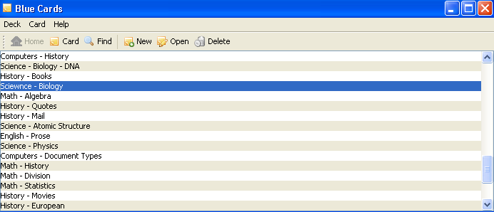
The Home panel, showing a card deck of study questions.
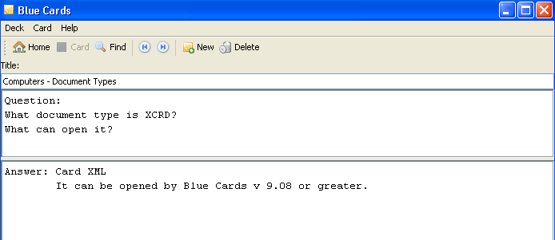
The card panel showing a card with a title, front and back.
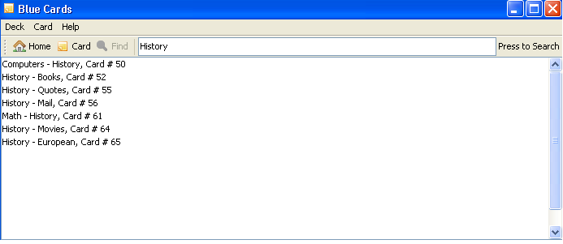
The find panel with an open search for items matching History.
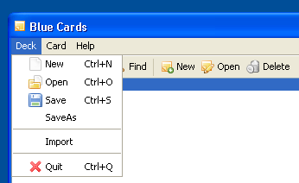Illustration 1: The Deck Menu

2.2.About Decks and Cards

The program Blue Cards allows you to open card deck files, (ending in xcrd), a card deck file is a file that holds cards, much like a case holds playing cards, cards are pages inside the deck file that you can edit and change just like index cards.

2.3.Creating a New Deck

Any time you open the program you have automatically created a new deck, this deck has only one card in it, it tells you to double click on it, if you do you will learn about the tutorial. If you already have a deck open you may make a new one by going to the deck menu and pressing new. You may also notice the Ctrl+N that is next to the button, this means that if you hold down the control key and press [n] it will also create a new deck.

2.4.Opening an Existing Deck

To open an existing deck press the Open button or press Control and O at the same time, this will create a new window and open the new deck inside it.
If there was an error opening the deck, a blank screen will show up and an error message should show informing you of the error.

2.5.Saving a Deck

You will want to save a deck once cards inside of it have been edited. To do this goto the deck menu and choose Save or hold control then press [s].

If you want to save the deck as something else you need to goto SaveAs, this will also allow you to save a document that you want two versions of, one with edits and one without.

2.6.Importing an Existing Deck

Importing allows you to move all of the cards from an existing deck into the one you are working on now. To do this goto the deck menu and choose import, after you confirm you wish to do this choose the deck you would like to import from.

2.7.Opening a Card
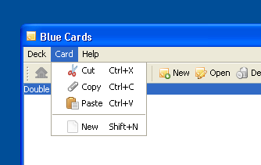Illustration 2: The Card Menu

To open a card you must be in the Home or search panes, from there you can double click on the title of the card you wish to open, or click on the card and press open on the menu bar. This will bring you to the card pane.

2.6.Creating a New Card

To create a new card you may goto the card menu and choose new, press Shift + [n], or from the home or card tool-bars choose New.

2.6.Deleting a Card

To delete a card while in the card panel you may press delete, while in the home panel press delete to delete any selected cards, to select multiple cards to delete hold the Control key and press on the cards you wish to select, then press delete, all highlighted cards will be deleted.
− | Select multiple cards in the Home or Search Frame by holding down control and pressing each card

! | Warning: Just like standard database software once you delete a card, there is no undoing it.

2.6.Importing an Existing Deck

Importing allows you to move all of the cards from an existing deck into the one you are working on now. To do this goto the deck menu and choose import, after you confirm you wish to do this choose the deck you would like to import from.

2.6.Importing an Existing Deck

Importing allows you to move all of the cards from an existing deck into the one you are working on now. To do this goto the deck menu and choose import, after you confirm you wish to do this choose the deck you would like to import from.

2.6.Importing an Existing Deck

Importing allows you to move all of the cards from an existing deck into the one you are working on now. To do this goto the deck menu and choose import, after you confirm you wish to do this choose the deck you would like to import from.

Chapter 1
1.1.Sub Chapter Title

Information goes here about this chapter and sub chapter. Information that goes in this chapter should be divided and simplistic to understand. Words that are important if this is a text book should be made bold or italicized. To make text look and feel good it should be in a justified mode, this means that the beginning and end of the text will fit entirely withing the window, allowing a standard and tight format.

! | Warnings go in a table such as this, Warning when you use justified the text will no longer be completely natural; meaning spaces are made larger or smaller, allowing words to fill up the entire screen.

− | Information that should be taken note of is placed in a dialog box such as this.

 | Quotes go in a box such as this. When you are done press Tab and add a name.  --A Name Goes Here

 | Things to check at the end of each Chapter.  - What did you learn?  - Did you read everything?

1.2.Pictures
This image of Tux has a caption, boarder, and shadow.
This is the second installment of the chapters, inserting images is quite easy. To insert an image goto Insert>Picture>From File the picture will be inserted and all you do is drag and drop it to where you want it to be, the text will form around it. If you right click and press picture you can add a boarder in the boarder tab, and a shadow as seen to the right. You can also goto the wrap tab and choose how you want the image to respond to your text, falling in line with it, allowing the text to go along with it (done on the right), etc. There is one more cool feature that will help you and that is the caption feature, right click and press caption. Under the properties area you can choose a word such as Image this will add a piece of text such as Image 1-1 before your text you do not want this usually however it is sometimes handy so for now choose none. Captions should use the caption style, as shown in the next sub chapter.

1.4 Styles and Formatting

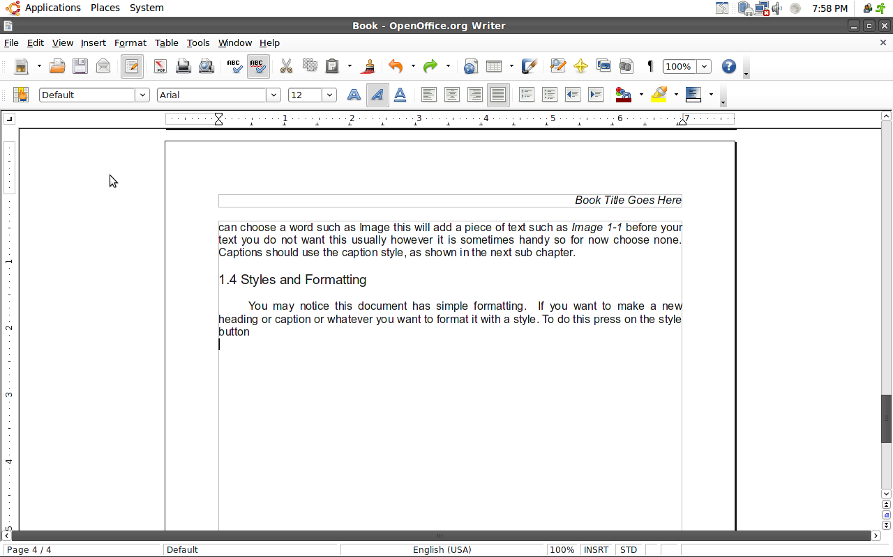
You may notice this document has simple formatting. If you want to make a new heading or caption or whatever you want to format it with a style. To do this press on the style button it is on your formatting tool-bar. To change your text highlight it and pull down the menu that says default right now and choose the proper heading.
- Default
  - Justified, Arial, 12pt.
- Chapter Title
  - Left, Arial, Bold, 20pt.
- Sub-Chapter
  - Left, Arial, 14pt.
- Caption
  - Arial, Italicized, 10pt., Centered

To change these press on the grid with the hand and the yellow, this will bring up a new frame in which you can right click and edit each one, the neat thing about styles is whenever you change a style all of the items styled like it will change too, allowing quick document changes.

− | To insert a new page, press [CTL]+[ENTER];
1.5 Changing Vital Information

To change the document owner, and such goto File>Properties.

Created by Joseph Lewis
08/18/09

